

**DRIVER MANAGEMENT system for matours**

Guaranteeing a perfect employer and a perfect driver



to be developed by:

Ernest M’mame

**DRIVER MANAGEMENT SYSTEM FOR MATOURS**

1. **OVERVIEW**

Matours is a Malawian transportation company that offers transportation services for people and goods. It has a variety of vehicles such as; trucks, lorries, buses, minibuses and taxi’s. The company has to hire the best drivers to ensure reliability and efficiency which maximise profits.

When recruiting new drivers, the vacancy is spread verbally, and drivers go to their Blantyre headquarters for an interview. They are required to bring their drivers licence and previous employers details.

Once a driver is hired, he/she is given a car based on skill set and this information is recorded in a book. All of the driver’s daily information is recorded here and is used as reference at the end of the month for assessing driver details and calculating the salary. When drivers are given a job, they are given a piece of paper with job details. If another branch requires information from another branch, the necessary details are photocopied from the book and taken by a driver going to that branch. This book is essential in driver keeping driver details, car details, salaries and all driver’s related data.

The current system has many problems;

First, it is hard to find drivers with the proper skill sets required by Matours. Job vacancies are poorly advertised as verbal advertisement is not far reaching and prone to bias to who receives this information. Having successfully hired drivers, storing the driver’s details is a problem especially Keeping track of which driver drives which car and which driver is handling which job. In addition, the book being paper based makes the information less secure and increases the likelihood of data loss via theft and uncertainties such as fire. Furthermore, there is no data backup meaning losing this book may have diverse effects on Matours. Data sharing and communicating with their other branches in Blantyre and Mzuzu is a problem. Just as the headquarters data is stored in a book and communicating information found on this book such as updates, is tedious task and slow. Drivers on a job experience problems when they lose the paper they are given and have to make phone calls for the data and this is an inconvenience. The final issues are that the details are usually available in Chichewa yet some drivers are more comfortable in English and have problems understanding this information as some of the drivers are not Malawians as this company is international.

Matours need an online system that improves vacancy sharing making it available to a lot of driver. The new system will keep driver, vehicle and job details as softcopies as these are easy to share and available at any time. In addition, it will generate reports automatically and will make them available when needed. An online driver database will be developed. Plus, the company will be able to send information to drivers and other company employees via email, SMS and chat sections on the application. Finally, the system will be in multiple languages i.e. English and Chichewa.

1. **AIM**

Developing an online system that will enable Matours find qualifies drivers, will keep track of the driver’s jobs, vehicles, send them messages and documents regardless of location and language.

1. **OBJECTIVES**
   1. **INVESTIGATING AND ANALYSING THE CURRENT SYSTEM**
      1. Research on how Matours locates and hires new drivers.
      2. Investigate how the company handles jobs.
      3. Analyse the grammar used by Matours so that this is available on the application.
      4. Research how other similar companies handle driver hiring and reports generation.
      5. Investigate they ways communicate with drivers away on some job and personnel at other branches.
      6. Gathering user requirements.
   2. **DESIGNING THE SYSTEM**
      1. Using Star UML to generate Use Case Models that show what individual users do.
      2. Generating Sequence diagrams to show how objects will interact with each other and how they work with their methods.
      3. Generation of a ERD diagram and Class diagram showing functionality and which information will be held.
      4. Designing the web applications interface using Microsoft Visio by creating wireframes that give a picture of how the interface will look like
   3. **DEVELOPING THE SYSTEM** 
      1. Developing the systems interface using bootstrap.
      2. Coding the functionalities using Atom Text editor in PDO.
   4. **TESTING AND IMPLEMENTING THE SYSTEM**
      1. Running black box, white box, integration and unit tests on all produced functionality and interface in an iterative and incremental way.
      2. Drawing test cases that documents all the tests and results
      3. Creating an evaluation table showing all requirments and detailing how each requirement has been tackled and met.
2. **PLAN AND METHODOLOGY**

The system will be developed Using the object-oriented Methodology. This methodology uses the Development Life Cycle (SDLC), MoSCoW prioritisation and UML diagrams. The SDLC is incremental, iterative and both technical and user oriented making sure the right product is developed at the end that does what is required and meets all user requirements.

Below is a table detailing the timeboxes for this system.

|  |  |  |  |
| --- | --- | --- | --- |
| **TASK** | **ACTIVITIES** | **START DATE** | **END DATE** |
| Literature review | * Research on driver management systems. * Investigate benefits of having an online job finding systems. * Look up on online databases and why they are essential. | 1st November 2017 | 15th November 2017 |
| Requirments capture | * Conduct interviews with different staff working at Matours. * Study how the current driver hiring and management works. | 16th November 2017 | 30th November 2017 |
| Requirments Analysis | * Go through collected information and point areas of concern and need of improvement. * Finding best solutions of discovered problems. * Communicating with users on solutions | 1st December 2017 | 20th December 2017 |
| System Design | * Using case tools to produce UML models | 21st December 2017 | 31th December 2017 |
| Implementation | * Developing database * Developing system interface. * Coding functionalities. | 1st January 2018 | 28th February 2018 |
| Testing | * Running various tests on application | 1st March 2018 | 15th March 2018 |
| Production of documentation | * Producing technical and user documentation documents | 16th March 2018 | 16th April 2018 |

* 1. **Gantt Chart**

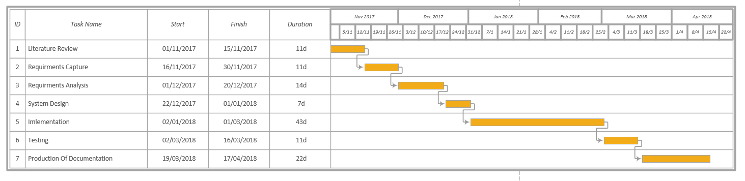

1. **RESCOURCE REQUIRMENT AND TOOLS**

The web application will be developed in HTML, PHP and JavaScript. It will use MySQL for the database. Atom text editor will be used for the coding and WAMP will be used to access the MySQL database. Models will be developed using Star UML to develop the ERD, Class diagram, Use case diagram.

1. **OTHER ISSUES AND CONCIDERATIONS**
   1. **Legal Issues**

* All details provided by the users will be confidential and secured respecting user privacy laws and intellectual property laws.
* The owners of the system are Matours and they will not use this ownership to tilt the system in their favour.
* All data fed to the system will be kept secure abiding to the Data Protection Law.
  1. **Social Issues**
* The system will not be cultural or ethically biased. All users will be able to use the system no matter culture or ethnicity.
  1. **Professional Issues**
* The system will not favour Matours in the hiring of drivers, they just own the system, but it will be used equally by all registered users

1. **REFFERENCES**